ML Project Results

Patient Exclusion Summary
Total patients: 533
Excluded due to missing death information: 7
Included in survival analysis: 526
Excluded from binary model (censored <12 months, outcome unknown): 72
Included in binary models: 454

Summary Table: Age at Diagnosis and OS Months
Variable | Mean | Median | Min | Max | Missing (n) | Missing (%)
age_at_diagnosis | 58.75 | 62.0 | 18.0 | 88.0 | 0 | 0.0
os_months | 19.17 | 10.01 | 0.03 | 102.87 | 0 | 0.0

Gene Mutation Summary Table
Gene | Positive (n) | Positive (%) | Negative (n) | Negative (%) | Missing (n) | Missing (%)
flt3_itd_cat | 121 | 23.0 | 405 | 77.0 | 0 | 0.0
npm1_cat | 145 | 27.57 | 381 | 72.43 | 0 | 0.0
runx1_cat | 64 | 12.17 | 462 | 87.83 | 0 | 0.0
asxl1_cat | 54 | 10.27 | 472 | 89.73 | 0 | 0.0
tp53_cat | 53 | 10.08 | 473 | 89.92 | 0 | 0.0

Sex Summary Table
Sex | Count | Percent
male | 290 | 55.13
female | 236 | 44.87
missing | 0 | 0.0
total | 526 | 100.0

Denovo Category Summary Table
denovo_cat | Count | Percent
true | 186 | 35.36
false | 339 | 64.45
missing | 1 | 0.19
total | 526 | 100.0

ELN 2017 Classification Summary Table
ELN class | Count | Percent
favorable | 173 | 32.89
intermediate | 121 | 23.0
adverse | 217 | 41.25
missing | 15 | 2.85
total | 526 | 100.0

Chromosome Category Summary Table
chromosome cat | Count | Percent
normal | 197 | 37.45
complex | 284 | 53.99
missing | 45 | 8.56
total | 526 | 100.0

Survival Models Harrell's C-index Comparison and AUROC at 12 months
Model | Mean C-index ± SD | Avg AUROC
Cox (ELN2017 classification) | 0.576 ± 0.027 | 0.666
Penalized Cox (ElasticNet) | 0.642 ± 0.023 | 0.774
Random Survival Forest | 0.707 ± 0.022 | 0.780
Gradient Boosted Survival (GBM) | 0.710 ± 0.023 | 0.777

Binary Models Performance (AUROCs and Brier scores)
Model | CV AUROC Mean | CV AUROC Std | CV Brier Mean | CV Brier Std
Logistic Regression | 0.765 | 0.049 | 0.198 | 0.021
RandomForest | 0.708 | 0.053 | 0.237 | 0.031
XGBoost | 0.672 | 0.055 | 0.299 | 0.041
MLP | 0.686 | 0.057 | 0.274 | 0.04

Model Hazard Ratios for each variables
Variable | Cox_HR | Cox_HR_CI_lower | Cox_HR_CI_upper | Logistic_OR | Logistic_OR_CI_lower | Logistic_OR_CI_upper
age_at_diagnosis | 1.0269 | 1.0184 | 1.0355 | 2.08 | 1.6232 | 2.6654
eln2017mode | 1.2658 | 1.1019 | 1.4541 | 1.9481 | 1.3703 | 2.7695
sex_male | 1.1356 | 0.9097 | 1.4175 | 1.4013 | 0.9027 | 2.1754
chromosome_cat_normal | 1.0 | 0.9996 | 1.0004 | 0.8604 | 0.5207 | 1.4216
denovo_cat_true | 1.1325 | 0.8995 | 1.426 | 1.4647 | 0.9249 | 2.3197
flt3_itd_cat_positive | 1.0 | 0.9993 | 1.0007 | 1.3168 | 0.7473 | 2.3204
npm1_cat_positive | 1.0 | 0.9991 | 1.0009 | 1.5188 | 0.7965 | 2.8962
runx1_cat_positive | 1.0 | 0.9995 | 1.0005 | 0.8631 | 0.4316 | 1.7258
asxl1_cat_positive | 1.0 | 0.9993 | 1.0007 | 1.0206 | 0.4916 | 2.1186
tp53_cat_positive | 1.949 | 1.3845 | 2.7436 | 3.0533 | 1.2865 | 7.2465

Model Importance Scores for each variable
Variable | XGB | GBM | MLP
age_at_diagnosis | 0.08489999920129776 | 0.5212 | 0.3472
eln2017mode | 0.22179999947547913 | 0.1872 | 0.2989
sex_male | 0.06199999898672104 | 0.0381 | 0.2772
chromosome_cat_normal | 0.07349999994039536 | 0.0193 | 0.2714
denovo_cat_true | 0.07729999721050262 | 0.0406 | 0.2661
flt3_itd_cat_positive | 0.12120000272989273 | 0.0153 | 0.3163
npm1_cat_positive | 0.07599999755620956 | 0.0403 | 0.3296
runx1_cat_positive | 0.0544000007212162 | 0.0074 | 0.3223
asxl1_cat_positive | 0.08749999850988388 | 0.0198 | 0.3582
tp53_cat_positive | 0.1412999927997589 | 0.1107 | 0.3391

Robustness Analysis: 1000 Bootstrap 95% CIs
Metric | Mean | 95% CI Lower | 95% CI Upper
Cox_age_at_diagnosis | 1.027 | 1.019 | 1.035
Logistic_age_at_diagnosis | 2.153 | 1.687 | 2.755
RF_age_at_diagnosis | 0.531 | 0.485 | 0.572
XGB_age_at_diagnosis | 0.097 | 0.071 | 0.125
GBM_age_at_diagnosis | 0.526 | 0.419 | 0.63
Cox_eln2017mode | 1.271 | 1.111 | 1.447
Logistic_eln2017mode | 2.009 | 1.433 | 2.812
RF_eln2017mode | 0.129 | 0.091 | 0.169
XGB_eln2017mode | 0.18 | 0.089 | 0.279
GBM_eln2017mode | 0.159 | 0.078 | 0.265
Cox_sex_male | 1.147 | 1.0 | 1.397
Logistic_sex_male | 1.445 | 0.927 | 2.172
RF_sex_male | 0.053 | 0.044 | 0.062
XGB_sex_male | 0.078 | 0.051 | 0.111
GBM_sex_male | 0.042 | 0.011 | 0.085
Cox_chromosome_cat_normal | 0.991 | 0.894 | 1.0
Logistic_chromosome_cat_normal | 0.883 | 0.527 | 1.339
RF_chromosome_cat_normal | 0.05 | 0.04 | 0.062
XGB_chromosome_cat_normal | 0.081 | 0.049 | 0.127
GBM_chromosome_cat_normal | 0.027 | 0.005 | 0.058
Cox_denovo_cat_true | 1.154 | 1.0 | 1.409
Logistic_denovo_cat_true | 1.516 | 0.935 | 2.336
RF_denovo_cat_true | 0.054 | 0.043 | 0.071
XGB_denovo_cat_true | 0.09 | 0.057 | 0.129
GBM_denovo_cat_true | 0.049 | 0.016 | 0.094
Cox_flt3_itd_cat_positive | 1.032 | 1.0 | 1.24
Logistic_flt3_itd_cat_positive | 1.378 | 0.785 | 2.319
RF_flt3_itd_cat_positive | 0.047 | 0.036 | 0.061
XGB_flt3_itd_cat_positive | 0.094 | 0.055 | 0.147
GBM_flt3_itd_cat_positive | 0.027 | 0.004 | 0.067
Cox_npm1_cat_positive | 1.037 | 1.0 | 1.241
Logistic_npm1_cat_positive | 1.601 | 0.89 | 2.855
RF_npm1_cat_positive | 0.032 | 0.024 | 0.042
XGB_npm1_cat_positive | 0.068 | 0.037 | 0.112
GBM_npm1_cat_positive | 0.044 | 0.012 | 0.084
Cox_runx1_cat_positive | 1.003 | 0.961 | 1.103
Logistic_runx1_cat_positive | 0.899 | 0.467 | 1.652
RF_runx1_cat_positive | 0.03 | 0.022 | 0.038
XGB_runx1_cat_positive | 0.069 | 0.038 | 0.116
GBM_runx1_cat_positive | 0.012 | 0.001 | 0.035
Cox_asxl1_cat_positive | 1.019 | 1.0 | 1.189
Logistic_asxl1_cat_positive | 1.089 | 0.5 | 2.057
RF_asxl1_cat_positive | 0.03 | 0.021 | 0.04
XGB_asxl1_cat_positive | 0.087 | 0.046 | 0.146
GBM_asxl1_cat_positive | 0.016 | 0.002 | 0.042
Cox_tp53_cat_positive | 1.991 | 1.529 | 2.591
Logistic_tp53_cat_positive | 3.266 | 1.501 | 6.465
RF_tp53_cat_positive | 0.045 | 0.025 | 0.07
XGB_tp53_cat_positive | 0.154 | 0.061 | 0.326
GBM_tp53_cat_positive | 0.099 | 0.051 | 0.165
Cindex_Cox | 0.713 | 0.686 | 0.741
Cindex_RSF | 0.843 | 0.827 | 0.859
Cindex_GBM | 0.8 | 0.778 | 0.824
AUROC_Logistic | 0.797 | 0.757 | 0.835
AUROC_RF | 0.999 | 0.998 | 1.0
AUROC_XGB | 0.999 | 0.998 | 1.0

Bootstrap Summary: C-index (Cox / RSF / GBM)
Metric | Mean | 95% CI Lower | 95% CI Upper
Cindex_Cox | 0.713 | 0.686 | 0.741
Cindex_RSF | 0.843 | 0.827 | 0.859
Cindex_GBM | 0.8 | 0.778 | 0.824

Bootstrap Summary: AUROC (Logistic / RF / XGB)
Metric | Mean | 95% CI Lower | 95% CI Upper
AUROC_Logistic | 0.797 | 0.757 | 0.835
AUROC_RF | 0.999 | 0.998 | 1.0
AUROC_XGB | 0.999 | 0.998 | 1.0

Time-dependent AUROC for Cox, RSF, GBM survival
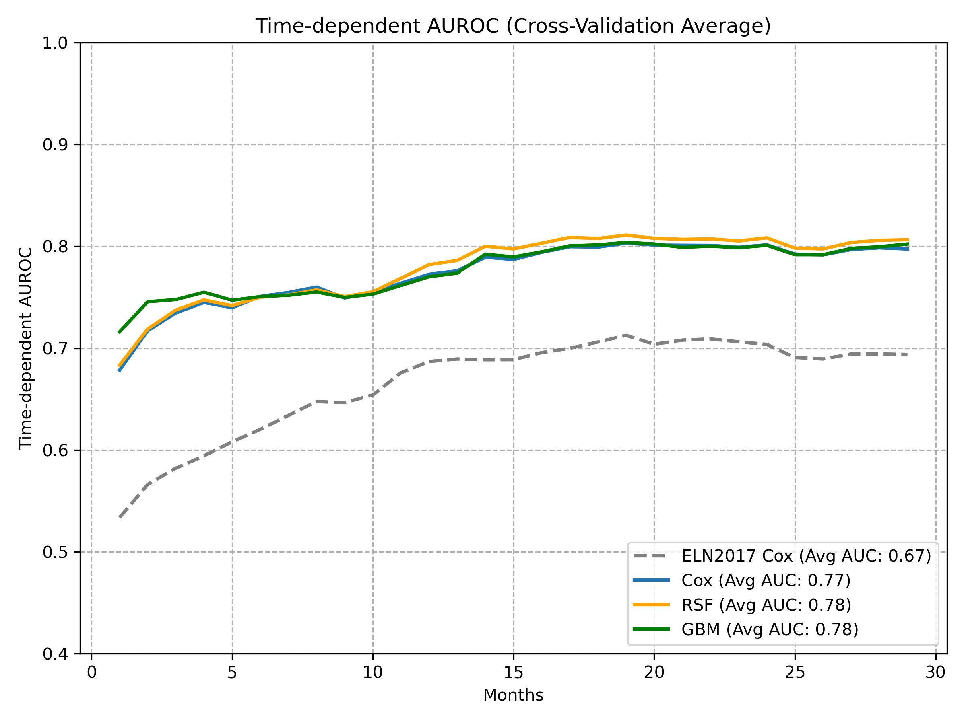

ROC Curves for Binary Models (Logistic Regression, Random Forest, XGBoost, MLP)
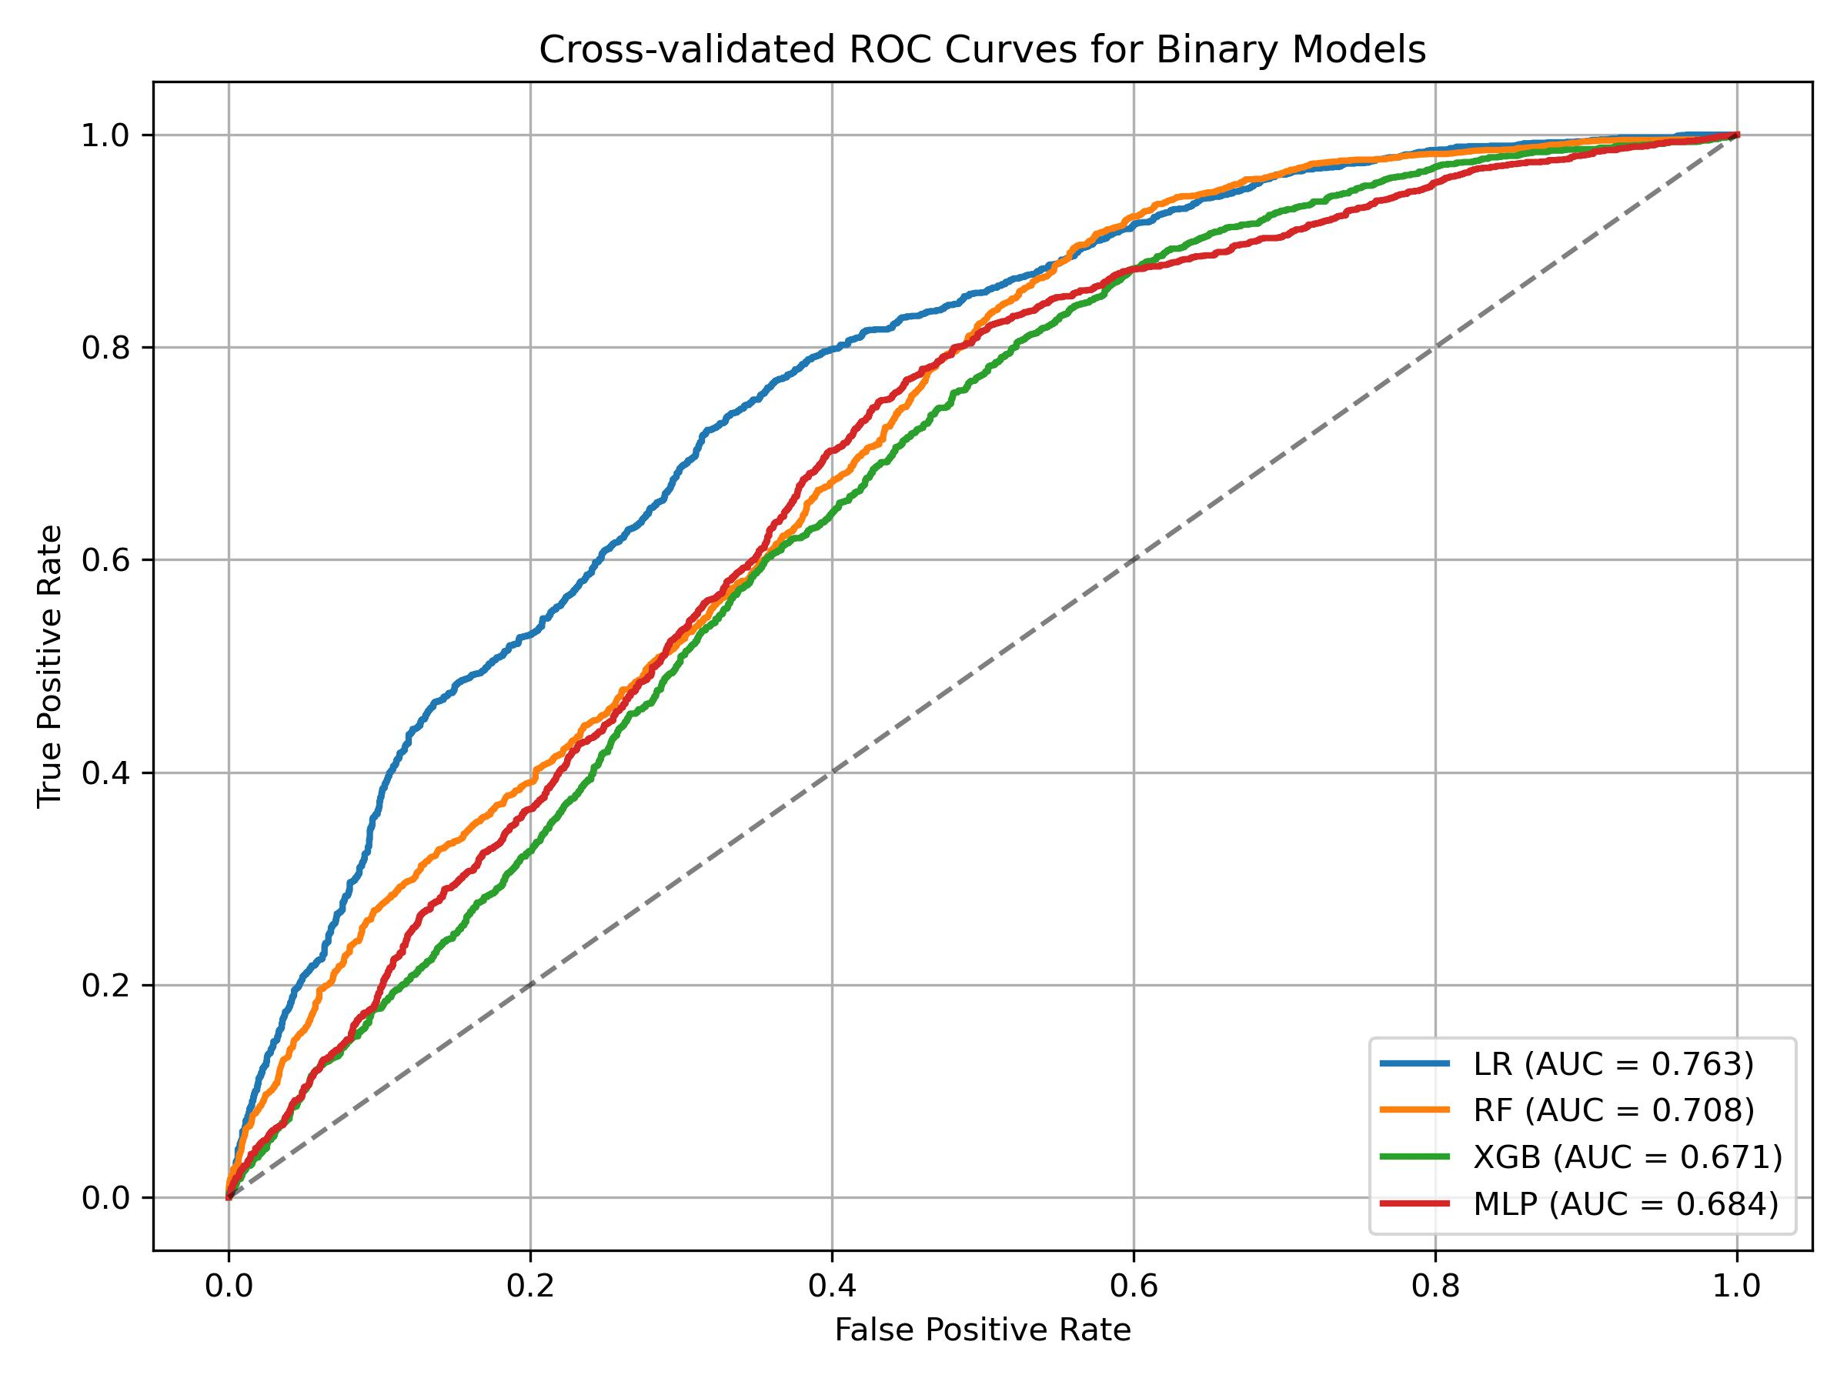

Calibration Plots for Binary Models (Logistic Regression, Random Forest, XGBoost, MLP)
